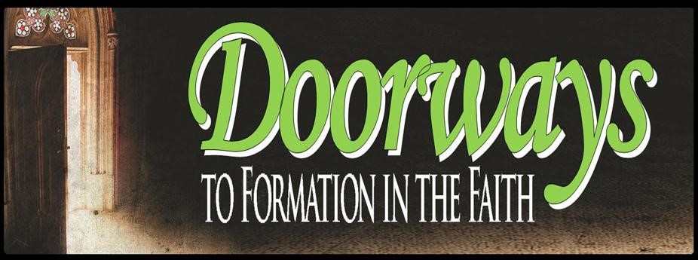

Course Evaluation

Thank you for participating in a Diocese of Raleigh Doorways course and for thoughtfully responding to the questions in this evaluation. These courses are meant to provide a basic understanding of the topic. Every response will be reviewed and used to determine modifications and enhancements to future courses. Additional comments are welcome, encouraged and may be used for promotional purposes.

- Were you able to attend all 6 sessions for a total of twelve hours? yes no
If you responded no how many did you attend?
(Note: The six sessions may have been offered over a period of two, three, four, or six different days as each session is 2 hours.)

- Did you clearly understand the expectations and outcome of this course? yes no
If you responded no please explain.

- What content and/or session(s) did you find most beneficial? Why?

- What content and/or session(s) did you find the least beneficial? Why?

- Do you feel prepared to explain the course content in your particular ministry? Explain.

- What other topic(s) or resources would you like to have available in the future?

- Was the cost of the course reasonable? yes no If you responded no, please explain.

